# Latent-Based solution Experiments

(Use KDE as anomaly metrics for the latent distribution)

## Experiments:

Use the same autoencoder architecture and loss function of reconstruction based

1. Problem n° 1: the latent space does not seem regular with normal patches:

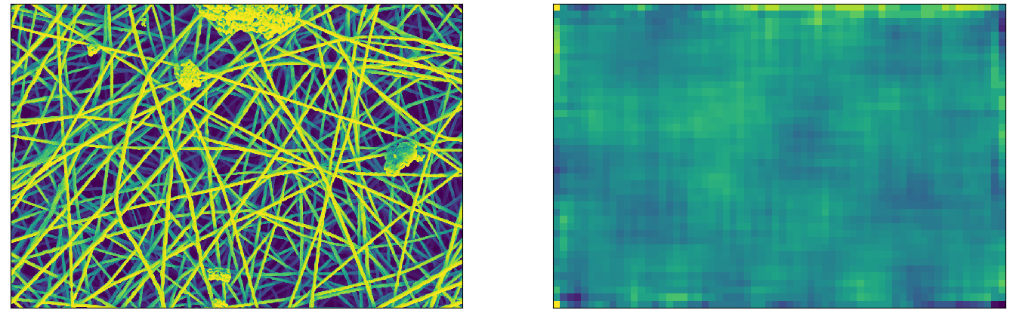

* 1. Solution: Regularize the loss function adding l2 penalty term: (Improving Representation Learning in Autoencoders via Multidimensional Interpolation and Dual Regularizations)

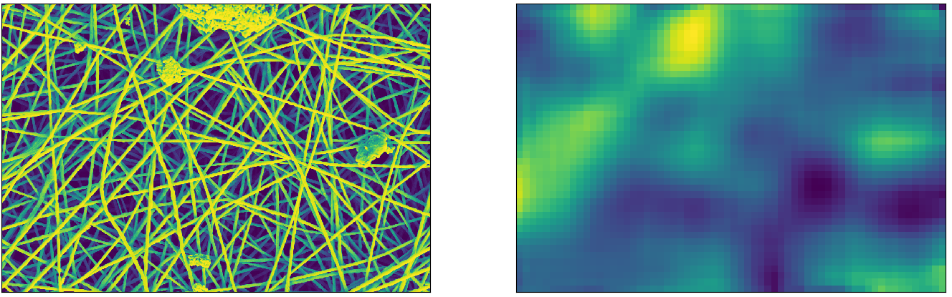

1. Problem n°2: the architecture is built in such a way that the input patch is 128x128 and it is reduced to a 1-dimension array of 512 elements. This fact reduces too much the resolution of the anomaly map, as we can see in the image above.
   1. Solution n°1: Reduce the patch dimension to 32x32 pixel

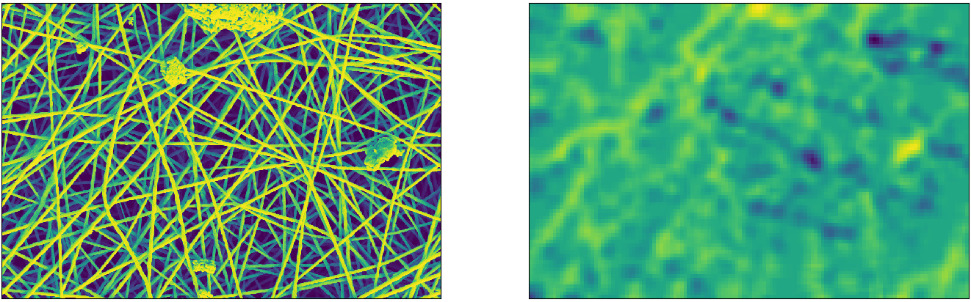

It seems that the autoencoder is not able to capture features of too small normal patches. In facts we can notice that the anomalies are reconstructed without changes.

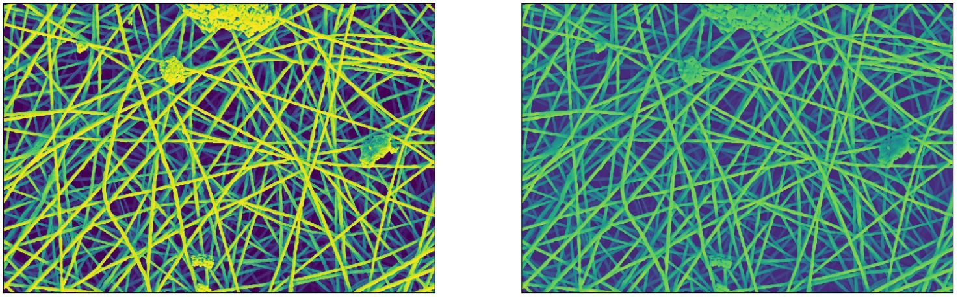

* 1. Solution n°2: Increase spatially the latent dimension, to 8x8x128. Now 64 features vectors are evaluated per 128x128 patch.

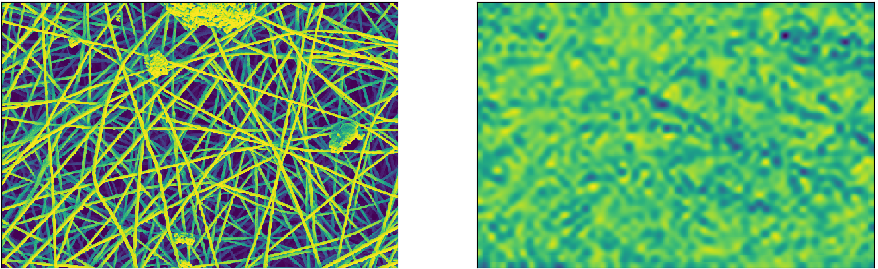

It seems that having a wide spatial latent dimension means do not extract features of normal patches correctly. In facts we can notice that the anomalies are reconstructed without changes.

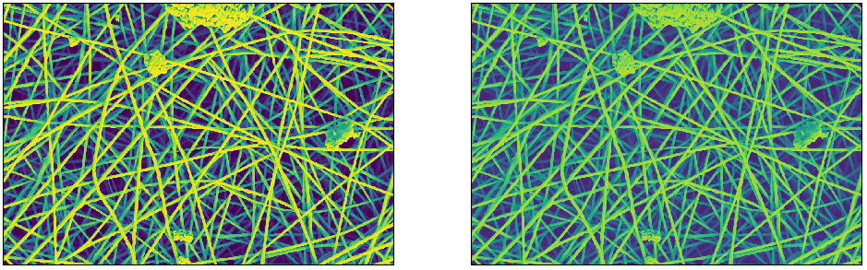

* 1. Solution n°3: But the above issue can be also attribute to the large number of features in the latent space (we are passed from 512 to 8192 features). We could try to use one layer before the latent one, in 1-dimension configuration of 512 elements. This layer has 4x4x256 dimension.

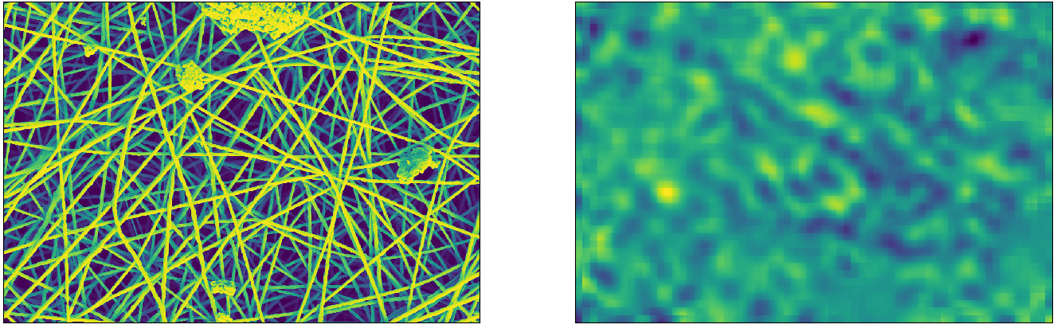

It seems that layers before the latent one are not enough. At least in this case the reconstruction is fine, so the bad reconstruction is not attribute to regularization.

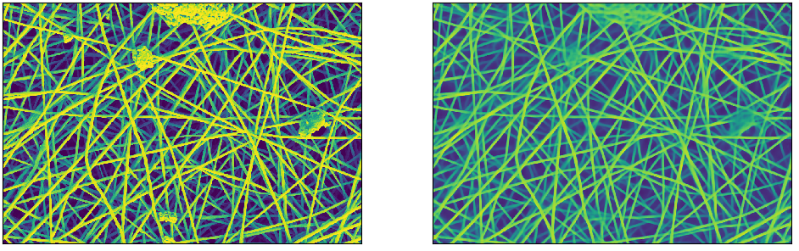

In the end:

1. Regularize the latent dimension is mandatory
2. Reduce the spatial input dimension would not lead to capture normal features
3. Increase spatially the latent dimension would increase too much the latent space
4. Layers before the latent do not capture enough information